**About us page:**

<http://wantro.com/creative2/about-us/about-us.php>

Animation on this page not work properly: text part hide more than half first image:

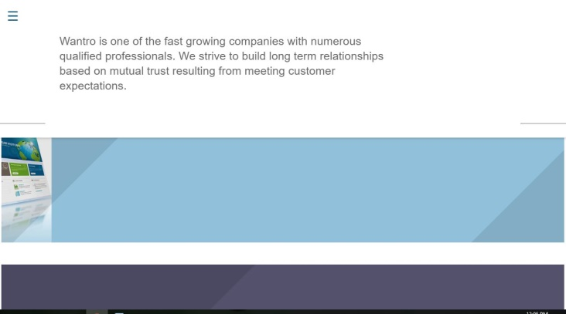

Image and text not aligned properly:

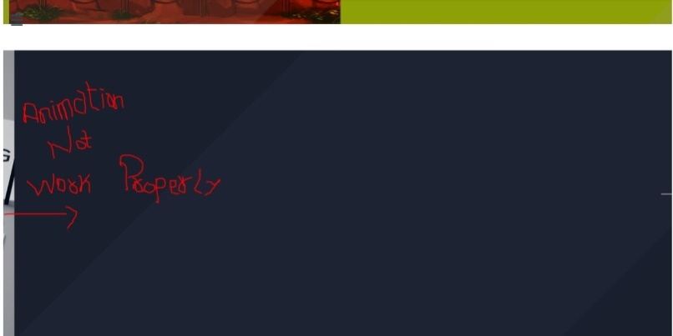

**Services Page:**

<http://wantro.com/creative2/services/index>

Menu missing

Resolve this Error

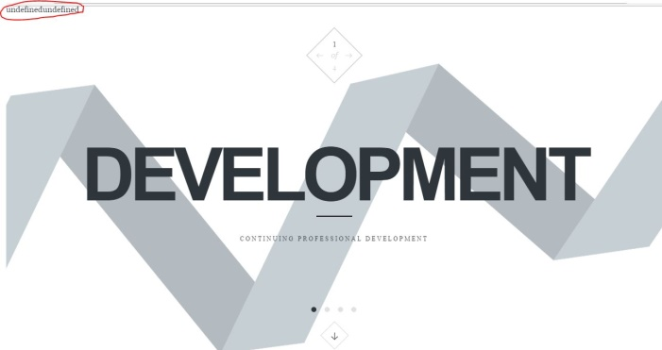

<http://wantro.com/creative2/services/promotion-campaigning.php>

Text missing: first paragraph is missing:

“The world of marketing is changing at a rapid pace. There are so many new developments taking place with the promotional and campaigning arena every day. At Wantro, our expert team of promotion and campaigning remains ahead of the curve. Our Promotion team is well versed with the latest online marketing trends.”

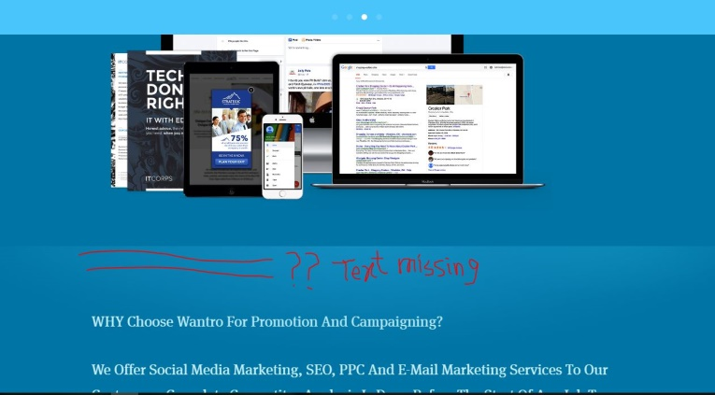

**Software development:**

<http://wantro.com/creative2/software-development/>

Heading of C# &VB.Net is missing

VB.net and C++ both have C# image

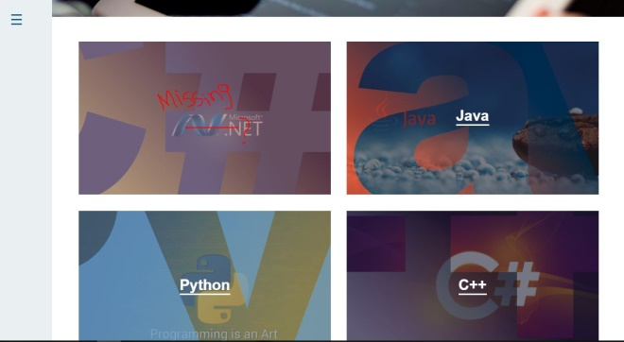

**Promotion Page:**

<http://wantro.com/creative2/Promotion/Space-Ape-Games.php>

Page scroll at the top when close any next page or click on the heading

<http://wantro.com/creative2/Promotion/space-project.php>

Set the image size on header of all promotion projects:

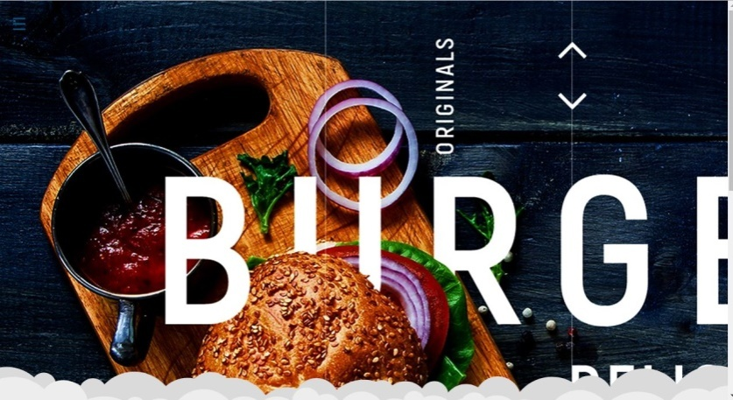

**Team Page:**

<http://wantro.com/creative2/Team/>

Team not opening page

Set images and text:

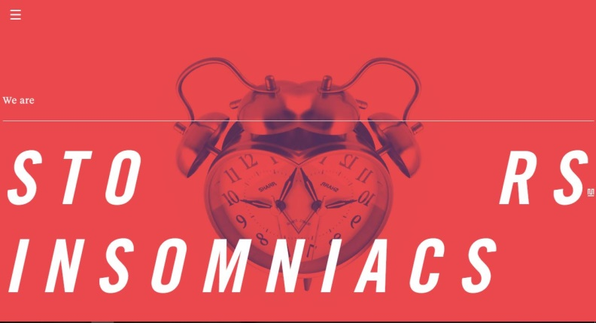

<http://wantro.com/creative2/Team/about-ceo>

Remove Colon sign:

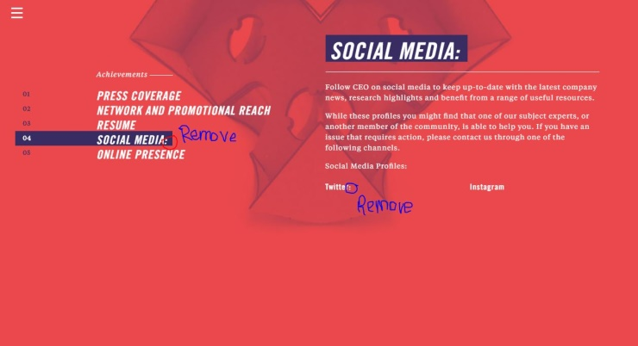

<http://wantro.com/creative2/Team/work>

Page scroll at the top at every click

Replace the image of David with David in “Higher Management”



Replace the NATASHA SPARE at fourth number with “Robin” “Art Director” from Designing



Add background color on all employees name to make it readable:



Change name to Chris:



Change content of Stefan in Game Development:

“Stefan takes care of programming and game design. Armed with logic and maths there’s nothing Stefan can’t build!

He earned his stripes during University studying computer science. He survived by exchanging PC repairs for vodka with the 5 art students he lived with. Despite losing his love for vodka, all things computer still engage him.

Stefan took his first step into video game production with a program combining a virtual pet hamster with Tetris. Awesome.”

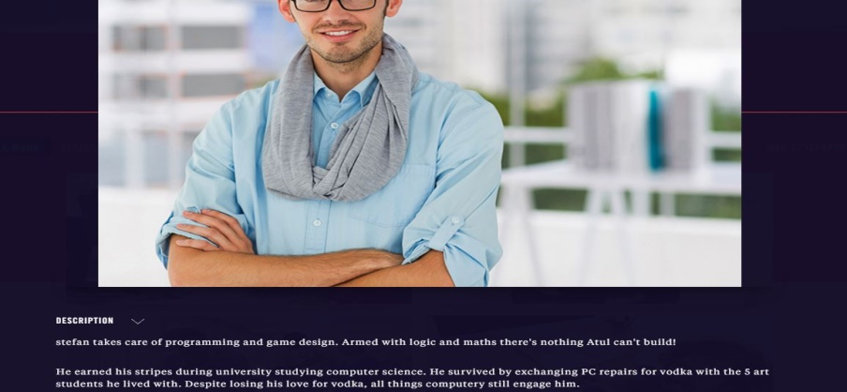

<http://wantro.com/creative2/Team/work?filter=social>

Change spellings of higher from Heigher

Cannot open the pop-up for information in Higher Management.

Change the hover effect on David Image in Higher Management. (only image shadow)

<http://wantro.com/creative2/Team/hr-manager>

In HR image of Monica cannot change in pop-up window

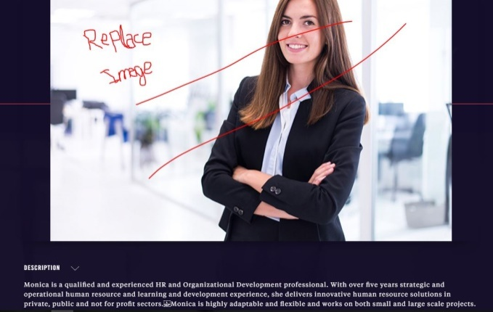

Change text of SAM in WebDevelopment:

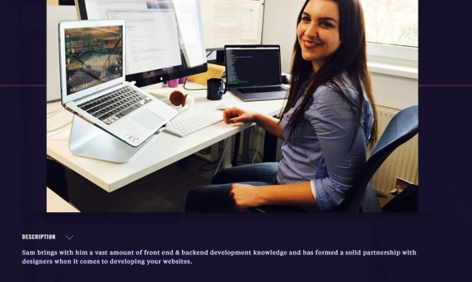

Sam is an expert at developing the technical mumbo-jumbo that goes on behind the pictures you see on your computer screen. With an initial background in digital marketing, Sam has combined this with her web development expertise to ensure a smooth and engaging user experience for your clients when they browse your website.

Change text of NITIN in web development

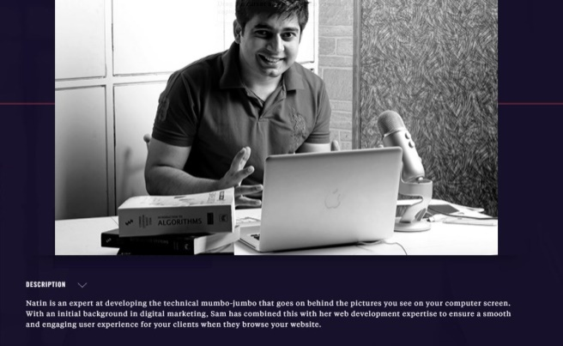

Nitin brings with him a vast amount of front end & backend development knowledge and has formed a solid partnership with designers when it comes to developing your websites.

<http://wantro.com/creative2/Team/teamlead>

Change name from Team Leads to Team Leads and management

Menu is not working on this page: Update content of this page:

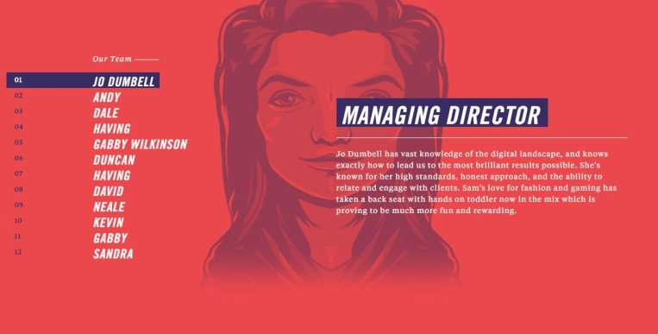

**Marketing Reach:**

<http://wantro.com/creative2/Marketing/>

Change content of this page:



Market Target Business

Marketing Reach

Content on button is not readable:

Remove the about or link it with About us page

**Testing:**

<http://wantro.com/creative2/Testing/index.php>

Change font color, it’s not readable

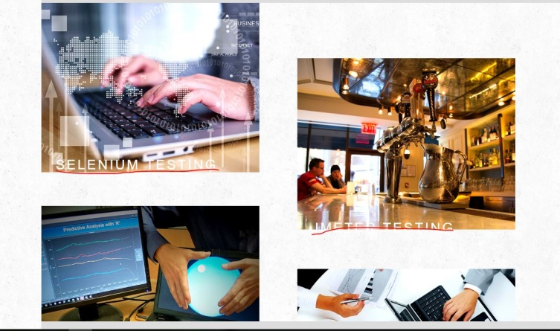

Next and previous button just change the background color but not text and image:

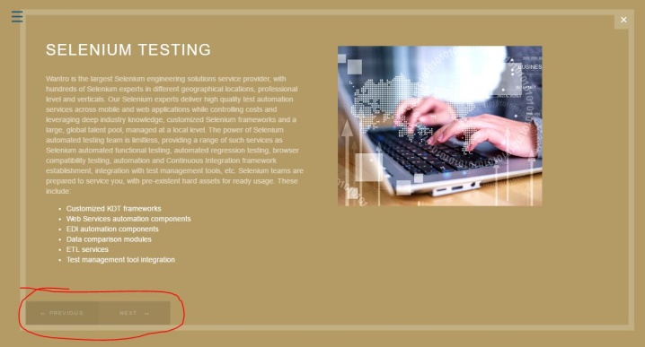

**Blog:**

<http://wantro.com/creative2/Blog/index.php>

text formation: “and” will be on next line.

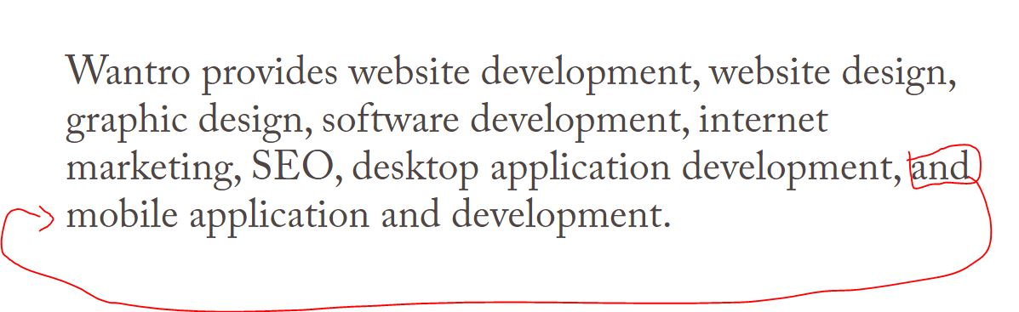

<http://wantro.com/creative2/Blog/technology.php>

Blog heading missing:

Decrease the font size of following text:

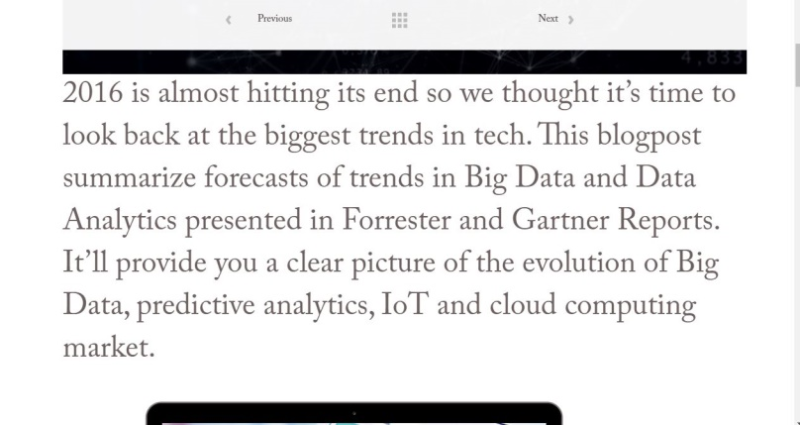

New paragraph will be started from marked point:

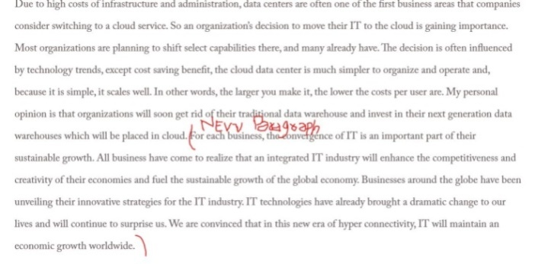

**Kickstarter:**

Page not open from menu: (404 error)

Menu not working properly:

<http://wantro.com/creative2/home/index.php>

Change image:

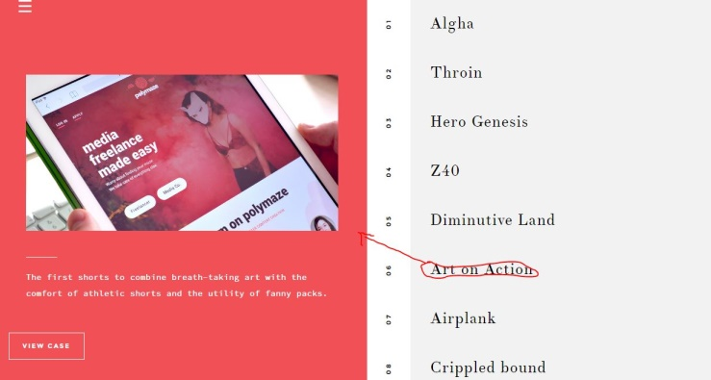

**PAGES MISSING:**

Web Development

Events

**Pages Not Done:**

Portfolio